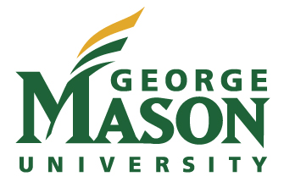
Mason Staff Senate
4400 University Drive, MS 5E5, Fairfax, Virginia 22030
Phone 703.993.4141; staffsenate@gmu.edu

Summer 2014 Staff Appreciation Coffee Klatch
Info Fair: Information for Departments

Thank you for expressing interest in participating in this summer’s staff appreciation events. We are hopeful that staff can learn more about the array of opportunities, services, events and other activities available to them. Departments may participate in one of two ways: by staffing a table at the event or by having literature (or other items) available to staff to pick up at the event.

Staffing a table: All of the events begin at 9:30 am. Please arrive prior to the event’s start. Each department will be allotted half a conference table for its display.

We hope that whenever appropriate departments will participate in the events at all three campuses.

Below are the details for each event.
Estimate
Event Date Location Attendance
Monday, July 7 Arlington 50
9:30 - 11:00 am Founders Hall 125

Thursday, July 10 Prince William 50
9:30 – 11:00 am Bull Run Hall Atrium

Wednesday, July 16 Fairfax 250
9:30 – 11:30 am Sub I, Patriot Lounge

Please complete the information below, confirming your intent to participate. You may mail, email or deliver the form to Kathrin Breitt Brown in University Hall 3500, MSN 5E5, kbreittb@gmu.edu. Registration is accepted on a first come, first served basis and space is limited.

Questions can be directed to Kathrin Breitt Brown, Administrative Assistant for the Staff Senate at kbreittb@gmu.edu or 3-4141.

Department _________________________________________________________________________

Contact Person_______________________________________________________________________

Phone ______________________________ Email _______________________________________

We will participate at the following campus(es)

Fairfax Arlington Prince William

